

**LIVRET D’EXERCICES- ADVF- CCP 1 et CCP2**

**Michaël PRUVOST**



**Généralités sur la communication**

1. **Qu’est -ce qu’un émetteur ?**

………………………………………………………………………………………………………………………………………………………………………………………………………………………………………………………………………………………………………………………………………………………………………………………………………………………………………………………………………………………………………………………………

1. **Qu’est- ce qu’un récepteur ?**

………………………………………………………………………………………………………………………………………………………………………………………………………………………………………………………………………………………………………………………………………………………………………………………………………………………………………………………………………………………………………………………………………………………………………………………………………………………………………………………..

1. **Qu’est-ce que l’écoute active ? Comment se traduit-elle ?**

…………………………………………………………………………………………………………………………………………………………………………………………………………………………………………………………………………………………………………………………………………………………………………………………………………………………………………………………………………………………………………………………………………………………………………………………………………………………………………………………………………………………………………………………………………………………………………………………………………………………………………………………………………………………………………………………………………………………………………………………………………………………………………..

1. **Un message peut ne pas être compris. D’où peut venir le problème ?**

…………………………………………………………………………………………………………………………………………………………………………………………………………………………………………………………………………………………………………………………………………………………………………………………………………………………………………………………………………………………………………………………………………………………………………………………………………………………………………………………………………………………………………………………………………………………………………………………………………………………………………………………………………………………………………………………………………………………………………………………………………………………………………………………………………………………………………

1. **Quand l’interlocuteur est long ou peu clair dans ses explications, que peut- on faire ?**

………………………………………………………………………………………………………………………………………………………………………………………………………………………………………………………………………………………………………………………………………………………………………………………………………………………………………………………………………………………………………………………………………………………………………………………………………………………………………………………………………………………………………………………………………………………………………………………………………………………………………………………………………………………………………………………………………………………………………………………………………………………………………………………………………………………………………………………………………………………………………………………………………………………………………………………………………………………………………………………………………………………………………………………………………………………………………………………………………………………………………………………………………………………………………………………………………………………………………………………………………………………………………………………………………………………………………………………………………………………………………………………………………………………………………………………………………………………………………………………………………………………………………………………………………………………………………………………………………………………………………………………………………………………………………………………………………………………………………………………………………………………………………………………………………………………………………………………………………………………………………………………………………………………………………………………………………………………………………………………………………………………………………………………………………………………………………………………………………………………………………………………………………………………………………………………………………………………………………………………………………………………………………………………………………………………………………………………………………………………………………………………………………………………………………………………………………………………………………………………………………………………………………………………………………………………………………………………………………………………………………………………………………………………………………………………………………………………………………………………………………………………………………………………………………………………………………………………………………………………………………………………………………………………………………………………………………………………………………………………………………………………………………………………………………………………………………………………………………………………………………………………………………………………………………………………………………………………………………………………………………………………………………………………………………………………………………………………………………………………………………………………………………………………………………………………………………………………………………………………………………………………………………………………………………………………………………………………………………………………………………………………………………………………………………………………………………………………………………………………………………………………………………………………………………………………………………………………………………………………………………………………………………………………………………………………………………………………………………………………………………………………………………………………………………………………………………………………………………………………………………………………………………………………………………………………………………………………………………………………………………………………………………………………………………………………………………………………………………………………………………………………………………………………………………………………………………………………………………………………………………………………………………………………………………………………………………………………………………………………………………………

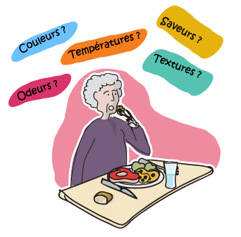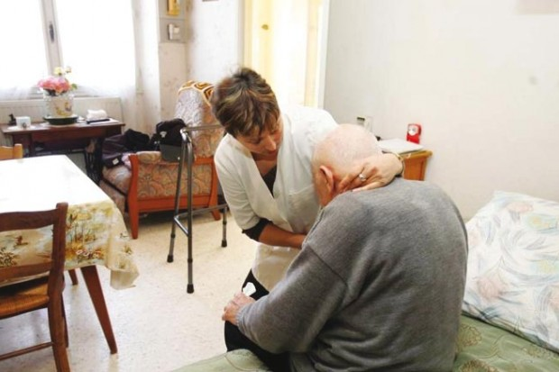

**Étude de cas**

Mme LION rentre de l’hôpital après une opération des yeux. Elle est fatiguée et déprimée. L’opération n’a pas été une réussite. Elle a une déficience visuelle (troubles liés à la fonction visuelle) importante.

Mme LION est entourée de sa famille. Elle apprécie la vie sociale et la lecture. Elle va souvent retrouver ses amies à un club de lecture. Elle vous emploie 4 matins par semaine de 8H à 11H30 pour l’aider à sa toilette, à l’habillage et pour l’accompagner dans ses déplacements. Vous serez en charge également de préparer le déjeuner.

1. **Décrivez vos actions d’une matinée.**
2. **Madame LION ne veut plus aller à son club, que lui répondez-vous ?**
3. **Elle vous demande d’aller à la banque chercher de l’argent, que lui répondez-vous ?**
4. **Vous avez trouvé cet emploi en répondant à une annonce mise par la famille de Mme LION, de quelle convention collective votre emploi direct dépend-il ?**

………………………………………………………………………………………………………………………………………………………………………………………………………………………………………………………………………………………………………………………………………………………………………………………………………………………………………………………………………………………………………………………………………………………………………………………………………………………………………………………………………………………………………………………………………………………………………………………………………………………………………………………………………………………………………………………………………………………………………………………………………………………………………………………………………………………………………………………………………………………………………………………………………………………………………………………………………………………………………………………………………………………………………………………………………………………………………………………………………………………………………………………………………………………………………………………………………………………………………………………………………………………………………………………………………………………………………………………………………………………………………………………………………………………………………………………………………………………………………………………………………………………………………………………………………………………………………………………………………………………………………………………………………………………………………………………………………………………………………………………………………………………………………………………………………………………………………………………………………………………………………………………………………………………………………………………………………………………………………………………………………………………………………………………………………………………………………………………………………………………………………………………………………………………………………………………………………………………………………………………………………………………………………………………………………………………………………………………………………………………………………………………………………………………………………………………………………………………………………………………………………………………………………………………………………………………………………………………………………………………………………………………………………………………………………………………………………………………………………………………………………………………………………………………………………………………………………………………………………………………………………………………………………………………………………………………………………………………………………………………………………………………………………………………………………………………………………………………………………………………………………………………………………………………………………………………………………………………………………………………………………………………………………………………………………………………………………………………………………………………………………………………………………………………………………………………………………………………………………………………………………………………………………………………………………………………………………………………………………………………………………………………………………………………………………………………………………………………………………………………………………………………………………………………………………………………………………………………………………………………………………………………………………………………………………………………………………………………………………………………………………………………………………………………………………………………………………………………………………………………………………………………………………………………………………………………………………………………………………………………………………………………………………………………………………………………………………………………………………………………………………………………………………………………………………………………………………………………………………………………………………………………………………………………………………………………………………………………………………………………………………………………………………………………………………………………………………………………………………………………………………………………………………………………………………………………………………………………………………………………………………………………………………………………………………………………………………………………………………………………………………………………………………………………………………………………………………………………………………………………………………………………………………………………………………………………………………………………………………………………………………………………………………………………………………………………………………………………………………………………………………………………………………………………………………………………………………………………………………………………………………………………………………………………………………………………………………………………………………………………………………………………………………………………………………………………………………………………………………………………………………………………………………………………………………………………………………………………………………………………………………………………………………………………………………………………………………………………………………………………………………………………………………………………………………………………………………………………………………………………………………………………………………………………………………………………………………………………………………………………………………………………………………………………………………………………………………………………………………………………………………………………………………………………………………………………………………………………………………………………………………………………………………………………………………………………………………………………………………………………………………………………………………………………………………………………………………………………………………………………………………………………………………………………………………………………………………………………………………………

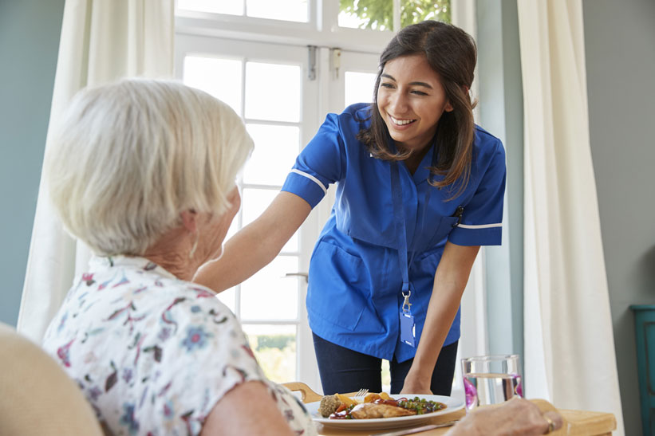

Instaurer un climat de confiance avec la personne aidée

1. **Qu’elle doit être l’apparence générale (tenue vestimentaire- présentation ) de l’ADVF s’occupant de la personne âgée et de l’enfant ?**

………………………………………………………………………………………………………………………………………………………………………………………………………………………………………………………………………………………………………………………………………………………………………………………………………………………………………………………………………………………………………………………………………………………………………………………………………………………………………………………………………………………………………………………………………………………………………………………………………………………………………………………………………………………………………………………………………………………………………………………………………………………………………………………………………………………………………………………………………………………………………………………………………………………………………………………………………………………………………………………………………………………………………………………………………………………………………………………………………………………………………………………………………………………………………………………………………………………………………………………………………………………………………………………………………………………………………………………………………………………………………………………………………………………………………………………………………………………………………………………………………………………………………………………………………………………………………………………………………………………………………………………………………………………………………………………………………………………………………………………………………………………………………………………………………………………………………………………………………………………………………………………………………………………………………………………………………………………………………………………………………………………………………………………………………………………………………………………………………………………………………………………………………………………………………………………………………………………………………………………………………………………………………………………………………………………………………………………………………………………………………………………………………………………………………………………………………………………………………………………………………………………………………………………………………………………………………………………………………………………………………………………………………………………………………………………………………………………………………………………………………………………………………………………………………………………………………………………………………………………………………………………………………………………………………………………………………………………………………………………………………………………………………………………………………………………………………………………………………………………………………………………………………………………………………………………………………………………………………………………………………………………………………………………………………………………………………………………………………………………………………………………………………………………………………………………………………………………………………………………………

………………………………………………………………………………………………………………………………………………………………………………………………………………………………………………………………………………………………………………………………………………………………………………………………………………………………………………………………………………………………………………………………………………………………………………………………………………………………………………………………………………………………………………………………………………………………………………………………………………………………………………………………………………………………………………………………………………………………………………………………………………………………………………………………………………………………………………………………………………………………………………………………………………………………………………………………………………………………………………………………………………………………………………………………………………………………………………………………………………………………………………………………………………………………………………………………………………………………………………………………………………………………………………………………………………………………………………………………………………………………………………………………………………………………………………………………………………………………………………………………………………………………………………………………………………………………………………………………………………………………………………………………………………………………………………………………………………………………………………………………………………………………………………………………………………………………………………………………………………………………………………………………………………………………………………………………………………………………………………………………………………………………………………………………………………………………………………………………………………………………………………………………………………………………………………………………………………………………………………………………………………………………………………………………………………………………………………………………………………………………………………………………………………………………………………………………………………………………………………………………………………………………………………………………………………………………………………………………………………………………………………………………………………………………………………………………………………………………………………………………………………………………………………………………………………………………………………………………………………………………………………………………………………………………………………………………………………………………………………………………………………………………………………………………………………………………………………………………………………………………………………………………………………………………………………………………………………………………………………………………………………………………………………………………………………………………………………………………………………………………………………………………………………………………………………………………………………………………………………………………………………………………………………………………………………………………………………………………………………………………………………………………………………………………………………………………………………………………………………………………………………………………………………………………………………………………………………………………………………………………………………………………………………………………………………………………………………………………………………………………………………………………………………………………………………………………………………………………………………………………………………………………………………………………………………………………………………………………………………………………………………………………………………………………………………………………………………………………………………………………………………………………………………………………………………………………………………………………………………………………………………………………………………………………………………………………………………………………………………………………………………………………………………………………………………………………………………………………………………………………………………………………………………………………………………………………………………………………………………………………………………………………………………………………………………………………………………………………………………………………………………………………………………………………………………………………………………………………………………………………………………………………………………………………………………………………………………………………………………………………

1. **Vous arrivez chez une nouvelle personne âgée comme aide-ménagère. Décrivez votre organisation lors de votre intervention ?**

………………………………………………………………………………………………………………………………………………………………………………………………………………………………………………………………………………………………………………………………………………………………………………………………………………………………………………………………………………………………………………………………………………………………………………………………………………………………………………………………………………………………………………………………………………………………………………………………………………………………………………………………………………………………………………………………………………………………………………………………………………………………………………………………………………………………………………………………………………………………………………………………………………………………………………………………………………………………………………………………………………………………………………………………………………………………………………………………………………………………………………………………………………………………………………………………………………………………………………………………………………………………………………………………………………………………………………………………………………………………………………………………………………………………………………………………………………………………………………………………………………………………………………………………………………………………………………………………………………………………………………………………………………………………………………………………………………………………………………………………………………………………………………………………………………………………………………………………………………………………………………………………………………………………………………………………………………………………………………………………………………………………………………………………………………………………………………………………………………………………………………………………………………………………………………………………………………………………………………………………………………………………………………………………………………………………………………………………………………………………………………………………………………………………………………………………………………………………………………………………………………………………………………………………………………………………………………………………………………………………………………………………………………………………………………………………………………………………………………………………………………………………………………………………………………………………………………………………………………………………………………………………………………………………………………………………………………………………………………………………………………………………………………………………………………………………………………………………………………………………………………………………………………………………………………………………………………………………………………………………………………………………………………………………………………………………………………………………………………………………………………………………………………………………………………………………………………………………………………………………………………………………………………………………………………………………………………………………………………………………………………………………………………………………………………………………………………………………………………………………………………………………………………………………………………………………………………………………………………………………………………………………………………………………………………………………………………………………………………………………………………………………………………………………………………………………………………………………………………………………………………………………………………………………………………………………………………………………………………………………………………………………………………………………………………………………………………………………………………………………………………………………………………………………………………………………………………………………………………………………………………………………………………………………………………………………………………………………………………………………………………………………………………………………………………………………………………………………………………………………………………………………………………………………………………………………………………………………………………………………………………………………………………………………………………………………………………………………………………………………………………………………………………………………………………………………………………………………………………………………………………………………………………………………………………………………………………………………………………………………………………………………………………………………………………………………………………………………………………………………………………………………………………………………………………………………………………………………………………………………………………………………………………………………………………………………………………………………………………………………………………………………………………………………………………………………………………………………………………………………………………………………………………………………………………………………………………………………………………………………………………………………………………………………………………………………………………………………………………………………………………………………………………………………………………………………………………………………………………………………………………………………………………………………………………………………………………………………………………………………………………………………………………………………………………………………………………………………………………………………………………………………………………………………………………………………………………………………………………………………………………………………………………………………………………………………………………………………………………………………………………………………………………………………………………………………………………………………………………………………………………………………………………………………………………………………………………………………………………………………………………………………………………………………………………………………………………………………………………………………………………………………………………………………………………………………………………………………………………………………………………………………………………………………………………………………………………………………………………………………………………………………………………………………………………………………………………………………………………………………………………………………………………………………………………………………………………………………………………………………………………………………………………………………………………………………………………………………………………………………………………………………………………………………………………………………………………………………………………………………………………………………………………………………………………………………………………………………………………………………………………………………………………………………………………………………………………………………………………………………………………………………………………………………………………………………………………………………………………………………………………………………………………………………………………………………………………………………………………………………………………………………………………………………………………………………………………………………………………………………………………………………………………………………………………………………………………………………………………………………………………………………………………………………………………………………………………………………………………………………………………………………………………………………………………………………………………………………………………………………………………………………………………………………………………………………………………………………………………………………………………………………………………………………………………………………………………………………………………………………………………………………………………………………………………………………………………………………………………………………………………………………………………………………………………………………………………………………………………………………………………………………………………………………………………………………………………………………………………………………………………………………………………………………………………………………………………………………………………………………………………………………………………………………………………………………………………………………………………………………………………………………………………………………………………………………………………………………………………………………………………………………………………………………………………………………………………………………………………………………………………………………………………………………………………………………………………………………………………………………………………………………………………………………………………………………………………………………………………………………………………………………

Connaissance du métier

1. **Quelle est le rôle de l’ADVF ?**

**Le Rôle de l’A.D.V.F**

1. **Quelles sont les limites de ses compétences ?**